How to use Mike Watts Horse driving trials spreadsheet
29-May-2019 version
Here are some notes on how to use this scoring spreadsheet.
Please let me know any problems or suggestions at m@mikewatts.com. Please look on www.mikewatts.com for the latest version and check back occasionally for updates.

Introduction

This document describes an Excel horse driving trials scoring spreadsheet in wide use in the UK and available free of charge. The design intent is that the basic spreadsheet is obvious to anyone who knows Excel (I have tried to keep it simple) – all the data for a driver on one line, nothing too fancy.

If you have used this before and want to see the recent changes please look at the section Changes in the scoring template, Details tab.

There is a fancy bit: I have added forms which make it much easier to enter data into this base spreadsheet. These forms are written in VBA – the language used in Microsoft Office, but the code is open. You can always enter data directly into the spreadsheet and ignore the forms – that means someone familiar with Excel but not programming can still have complete control of the spreadsheet and get at all the data. It has extensive event timetabling functions.

It can also post results direct to the web in one click.

It works on at least: Excel 2007 and 2010, 2016, Windows 7, 8 and 10. I’m sorry, it does not work on Mac or iPad.
You need to have Excel, on Windows to use it.

Each of the sheets is `protected`. This is to stop you accidentally overtyping formula cells which do the calculating. It is not passworded, so you can simply unprotect sheets if you need to alter anything protected. You should not generally need to do that, and if you do unprotect a sheet, please take care how you change nay formulae and be sure to protect the sheet again afterwards to avoid mistakes.
However, it has extra features to make it easy to use on top of a simple Excel spreadsheet, in particular it has

- optional forms for entering Presentation, P&P, cones, section times, Eliminate/Withdraw etc and obstacles.
- support for printing results
- support for scheduling dressage and marathon times
- calculation of cones times by class
- FEI penalties reference

In addition it has advanced features, which you can use if wanted:

- it can easily post final or intermediate results direct to the hdtforum driving website, when connected to the internet.
- it can drive other PCs to show live display of results
- it can allow more than one PC to enter data at once, to share the work and in case of a PC failure

This is very similar to my indoor driving scoring spreadsheet, expanded for outdoor events.

Setting up

Take a copy of the template spreadsheet and rename it for the event you will score. Now work on that spreadsheet you have created for your event. Of course you can copy the template to different filenames to try it out while you are getting to know the system, discarding test spreadsheets later.

When you open a scoring spreadsheet, be sure that ‘active content’ (macros) are enabled – otherwise the buttons won’t do anything. See faqs section for more information on this.

After setting up the details, all the results show up and scoring is done on the `Master` sheet, which we`ll describe shortly.

Setting the Event details
Click the tab Details and type them in where highlighted below. Entry areas are mostly yellow.

Event name, 3 day or 2 day style.
Before you start scoring you need to choose:
- the event type, “How many days”: 3 day (cones last) or 2 day style (cones after dressage)
- how many obstacles, and
- how many judges (1-5)

Other details can be entered later if necessary, including
- Allow 0.5 in dressage (so scores can b 5, 5.5, 6.5 etc – 2013 rule change, if you use it)
- Judges names
- Whether you have Standing presentation
- Your local name for the Prenovice class (Introductory is accepted if you need to be different)
- Penalties per knockdown and per second in the obstacles in case you are using an unusual scoring system

Cones details
Here you can enter the cones numbers – e.g 1,2,3… or 1,2,3a,3b,3c, 3d,…
Just enter as many as your cones course will use (e.g. up to 15 or 20) and leave the rest blank, as below.

Click “Set cones details to master” when you`ve changed these details.

The easiest way to enter the cones distance is to click “Set cones length”- this will set it for all classes.

You can alter the cones distances, for any or all classes. Any time and the result will be immediately used in the calculations on the master score sheet, for new and any existing scores.

It is normal to set the cones length and let the programme work out the time in accordance with the rules. If you need instead to set a time, perhaps because the judge changes the time after the first three competitors, you most easily do that by adjusting the length to get the time you want, or unprotect the Details sheet and type the cones Time Allowed in directly.
You can also Unprotect the sheet and change the cones speeds – note they are set to BC rules, normally stick to these.

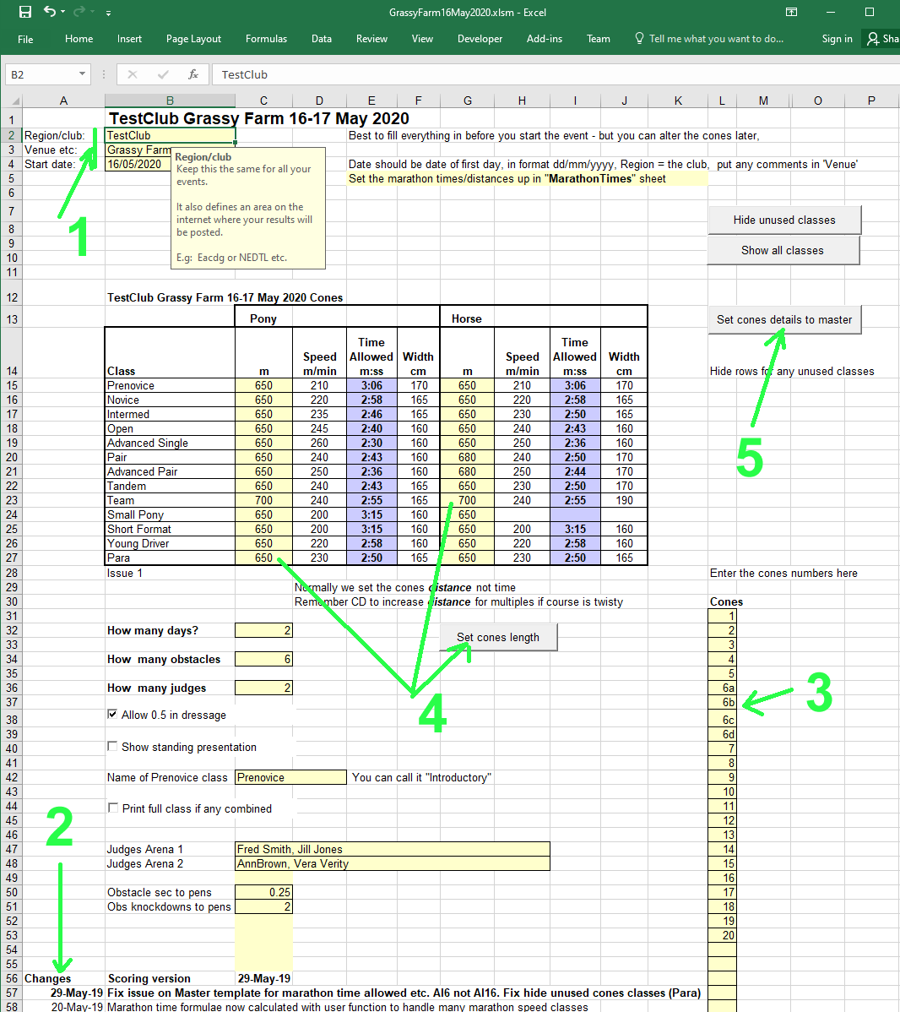

Setting up drivers
Go to the Drivers tab. If there any existing entries, delete them by clicking Delete All.

Type in or paste in the drivers` names and their class. If you use my online entries system, you paste it in from there.
If not, use a class name similar to that shown below so the spreadsheet can recognise it to get the right section/cones time. It recognises “pony”, “horse”, “small” and “prenovice” in the class names for the marathon, as well as pair, tandem and team for cones.

Combining classes
You don’t usually have to do this, but: sometimes an event combines classes where there are small numbers of entries. For example with only one Novice Horse and one Novice Pony you might decide to have a Novice class combining them. However, pony and horse go at different speeds in the marathon, so you leave their “Timings Class” as Novice Horse and Novice Pony respectively so they get allocated the correct speeds, but put them both in a “Score Class” called Novice so they get scored together. That’s why we have the two different columns, Score Class and Timings Class. If not combining classes, make every driver’s Score Class the same as their Timings Class.

We look at the entries and put symbols, like * or &, one the ends of names of pairs of drivers who are sharing carriage or groom etc and must be scheduled apart, just so they are easy to spot on the timetables.

Also set up which dressage test each driver is doing, under Test (e.g Novice, 1A). This is just to label and help with Dressage times scheduling.

Note that the “Number” will have a formula which gets the number from the MarathonTimes tab, by matching the driver`s name, later.

When you`re done, press “Copy to MarathonTimes”.
Normally we then go to the MarathonTimes tab and schedule the marathon, see below, as we like the numbers to be in marathon order as that`s the busiest day.
When you`re done scheduling the marathon, return here and press “Done – create scoresheet”
This will create a sheet called Master with your classes and drivers.

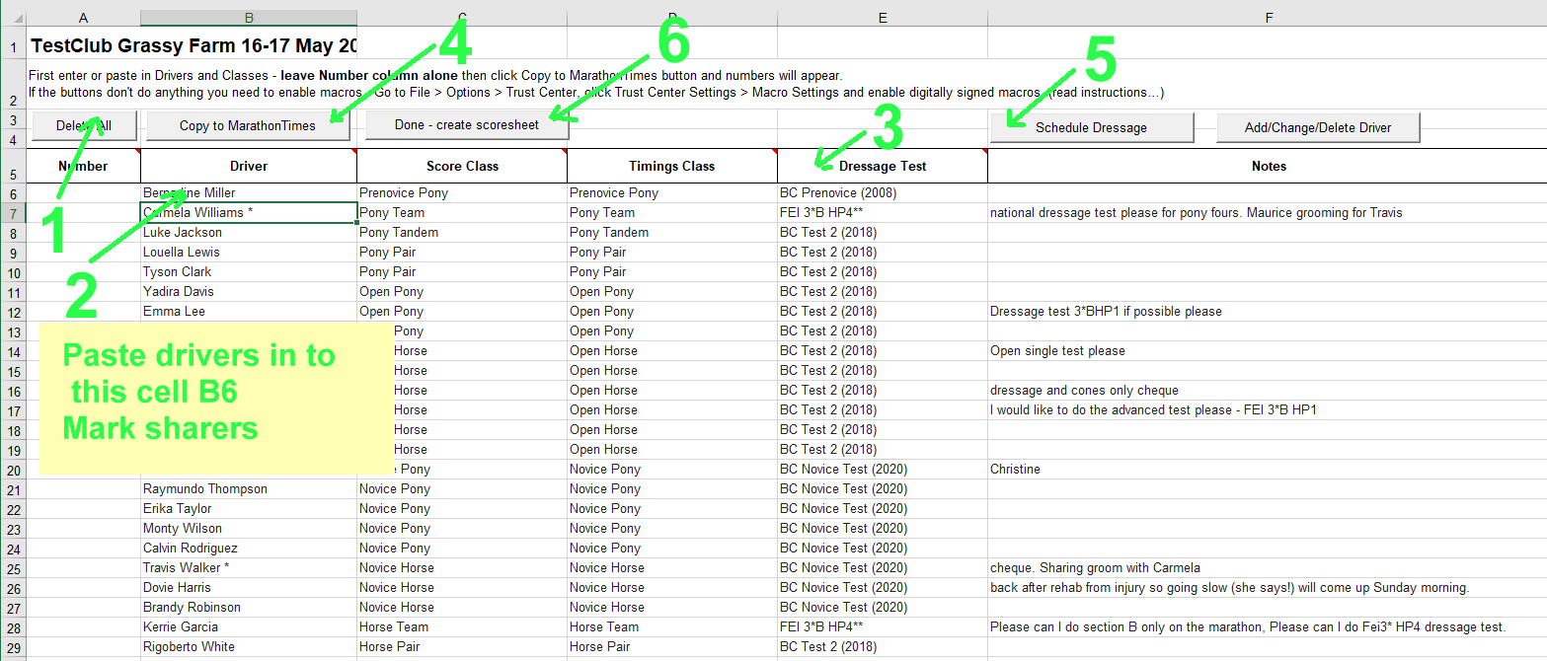

You can use extra columns on the Drivers tab to store extra information you may need, like notes about sharing carriages, meal tickets etc.

Marathon details
Click the MarathonTimes tab
Enter the marathon section lengths where highlighted (1,2,3) . Alter any speeds you need to (4).

The spreadsheet will show you the `raw` section times for A and B – some people round them up to the nearest minute or half minute above but it’s much better to use the exact time calculated by the spreadsheet, avoids confusing drivers.

The drivers and their classes have been filled in by clicking Copy to Marathon Times in the Drivers tab (go back and do that if you haven’t yet). Then, step by step, following the numbers in the figure below:

1 set the section lengths in km. If you type in the top cell, the others fill in.
2 adjust the section speeds if yours are non standard (kph)
3 adjust the “Time allowed” if you want to vary it from the calculated time (you should use the calculated time)
4 type in the Gap between sections (use Excel format e.g 0:3:00 for 3 minutes). The TB (Walk-E) gap needs to allow time for the Halt. Note: the spreadsheet will round up the start time of the next section to a whole minute, so people don`t start at 10:31:47, they start at 10:32:00)
5 use the Rearrange button to set up the marathon running order (more detail below)
6 now use the Schedule button to work out the marathon timetable (more detail below)

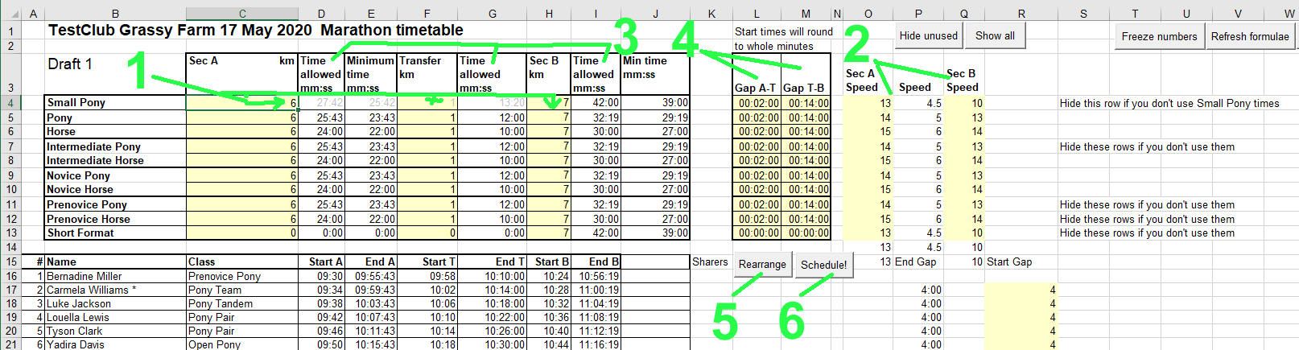

When you enter times on this sheet, use Excel`s native time format: 0:2:3.4 i.e h:m:s.s Note: Excel is picky about this.

You don`t have to use the marathon timetabling in this sheet, but it makes entering the section times a little easier, and of course you do need to enter the marathon Time alloweds for the section calculations to work in the scoring.

Normally we set consecutive numbers 1,2,3 in this sheet and let the other sheets use this as a master guide for competitor numbers. So if anyone is not doing the marathon, put them on this sheet just below the marathon timetable – number, name, class. The Rearrange dialog will do this for you.

If you paste in drivers (and their class) the spreadsheet will calculate their start and finish times. If you need to add more rows part way through scheduling use Add/Change/Delete Driver on the Drivers tab. If you try instead to insert rows direct into the marathon times sheet (I suggest don’t) then be careful to paste in or fill down the formulae in the time boxes – here you are close to using raw Excel. This is what the “Refresh formulae button” is for – to make sure the formulae haven`t got messed up if you copy and paste, delete etc. directly.

The section times allowed are used in the master spreadsheet automatically.

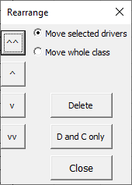
If you need to adjust the order of drivers in the marathon before the event, you can do this by selecting a one or more drivers and using the buttons on the Rearrange dialogue (click Rearrange) to move them up/down, one row or 10 at a time. Note that the driver numbers don`t move unless you have pressed Freeze numbers. We assume you want the marathon numbers to run in order and set the numbers from here.

If you want the driver numbers to move with the driver, click “Freeze numbers” before you use Rearrange. You would do this if you have to change the running order/timetable after you have given out driver numbers.

Calculating the marathon timetable

Press the Schedule button to display the Marathon Schedule dialog:

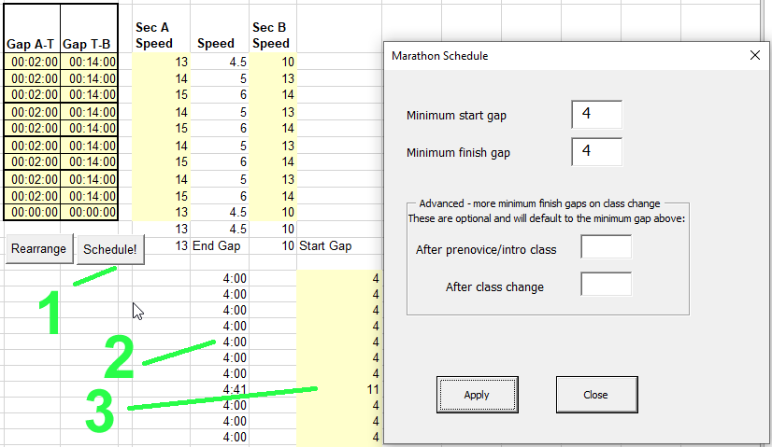

Because different classes go at different speeds, horses can catch up ponies, or ponies behind horses leave a large gap at the finish, the marathon timetable can take some juggling – that`s what the Schedule button fixes automatically.

You choose
- the minimum time gap between starters `Minimum start gap` you want (typically 3 or 4 minutes) and
- the minimum time you want between competitors at the finish (typically 4 minutes – don`t set it below the Section B time window of 3 minutes unless you want to risk competitors overtaking each other).

Some people have extra requirements, like an extra gap after prenovices (if they may be unpredictably slow), or an extra gap after each class change. You can set those, in minutes, or you can leave them blank.

Now press Apply. Have a look at the resulting timetable and see if you are happy with it. In particular, check the `End Gap` column, which tells you how many minutes there should be between people at the finish – normally you aim for at least 4 (minutes), but not too much more.

You can change the numbers in the Marathon Schedule dialog and re-Apply as many times as you like, until the timetable is how you want.

After automatic scheduling, you can tweak the schedule more by hand if you wish. This is not normally necessary, but; suppose you have a driver who is likely to be slow immediately before someone very competitive and fast. Go to the row of the fast driver, Start Gap column – R - and increase the number of minutes to get them as clear of the driver before as you want. All the other times adjust automatically.

If you call the Transfer “Walk” you can manually edit that title.

Dressage times

Return to the Drivers tab and click Schedule Dressage.

This gives you a dialog where you can choose which classes are in which arena (if there is more than one) and their order. It shows you numbers in each arena so you can aim for a balance:
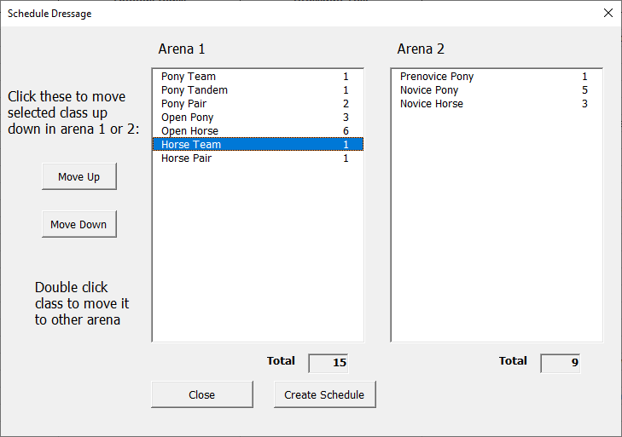

Set the classes as you want them, then click Create Schedule which will populate the Dressage Times tab:

- You can set the start time in the top left time – use Excel format like 09:00:00
- Use the Rearrange button and dialog to insert breaks and adjust the running order.
- Scroll down for Arena 2 if used.
Note if you are using two arenas into one cones arena you will want to schedule classes at the same time in arenas 1 and 2 who can share a cones width. You can adjust some 165 widths to 160 or 170 to minimise cones changes.

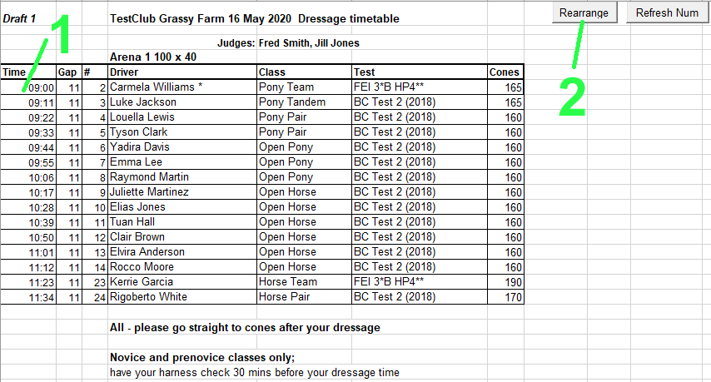

Scoring
The scoresheet (“Master”) is created once by clicking “Done - create scoresheet” on the Drivers tab.
To enter scores, always go to the Master sheet (click the tab marked Master at the bottom of Excel).

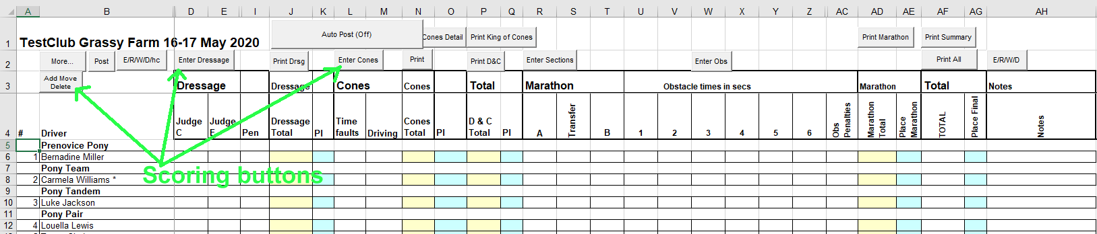

You can use the buttons near the top of the sheet to bring up data entry forms for each phase, or print.
These forms are also available from a Scoring menu, though Excel displays that in different places for different versions of Excel. Here is how it appears in Excel 2016:

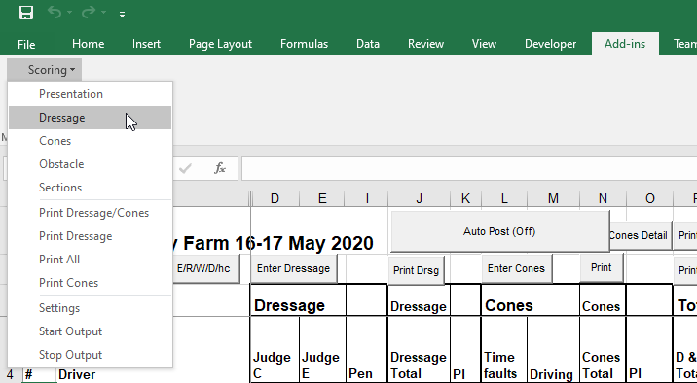

Example – the dressage score sheet
It doesn`t matter if you one or two or three or five judges, the sheet compensates (but you must use at least the first column, Judge at C). Also, it calculates the dressage coefficient by the number of scores you enter (e.g 16 movements or 20 etc).

You enter the driver number, then the scores, press Apply or the Enter key and it appears on the master sheet. You can return to this driver number/form later to edit scores if needed. All the forms work much the same way.

If you like, you can hide an unused judge column on the Master score sheet (you will have to go Tools Protection Unprotect Sheet to do that – I recommend you protect the sheet again afterwards to have less risk of accidentally overtyping a formula).

You can enter presentation, dressage, cones, obstacles and sections in any order. Total scores for a competitor won`t appear until the competition being totalled is complete for the competitor.

You can leave these forms open and just change the driver number to move on, or close them, as you like.

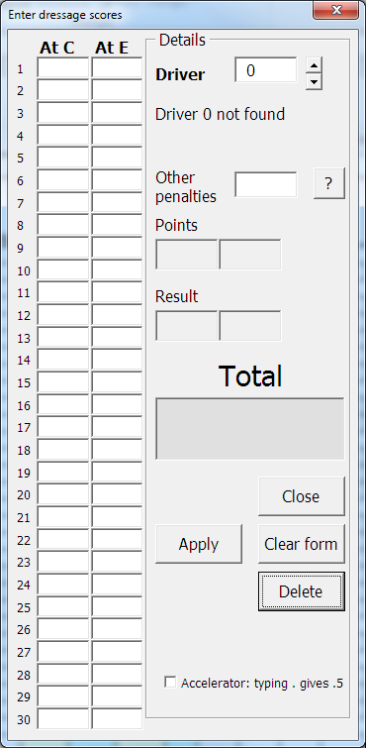

Rapid entry – just enter the numbers and they will go in successive boxes down the form. Type . to get 0.5.

Results from these forms are stored on the Master sheet (columns on the right) or Dressage sheet for dressage and presentation), and the forms retrieve them if you go back to the form – so you can check or alter scores.

Click the “?” button next to the Other penalties to see rule/penalty hints:
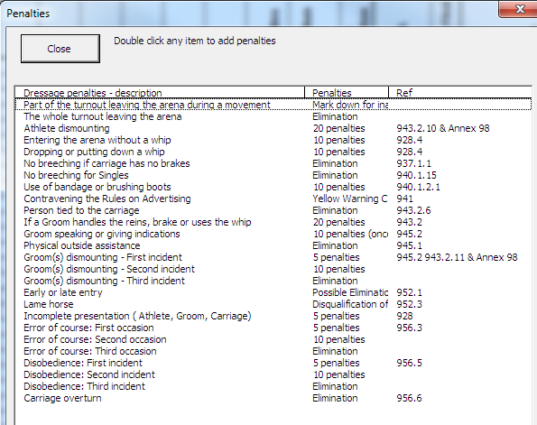

You can double click a row in this screen to apply the penalty in the dressage form (or just type it in).

These hints come from the tabs DressagePenalties, ConesPenalties and MarathonPenalties, so you can customise them for your club if needed (but then you`d need to reapply the customising to any new version of the spreadsheet I release…).

To eliminate/retire/wd/disqualify
Click a penalty that requires elimination or one of the “E/R/W/D” buttons and use this form to eliminate or uneliminate anyone. It`s best to add a note why, in “Note”to avoid queries from the drivers later. You can also type hc (or other abbreviations – any text excludes the driver from the placings).

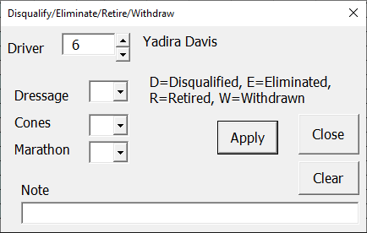

To enter cones

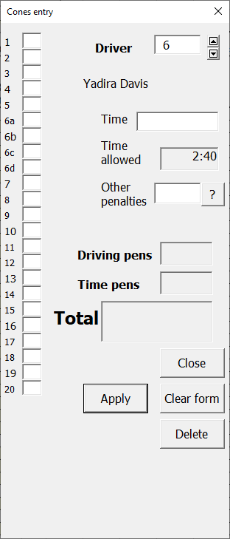

You can click a box for each cone down (the spreadsheet will allocate 3 penalties). If you like you can type 0 in each box to show a cone passed successfully, 1 for cone down, but the 0s are optional, blank means the same to the score.

You can enter the time for cones or obstacles in any of these formats:
- 123.4 – i.e seconds.decimal seconds
- 2 3.4 - i.e minutes space seconds.decimal seconds
- 169 - i.e. whole seconds (though this is outside the rules – cones and obstacle times should all be to two decimal places)
- 0:2:3.4 – Excel`s native time format (and that`s how it will show you the times in this box). h:m:s.s
On this form you can also click “?” to get values for other occurrences, like groom down etc, as for dressage/

Enter obstacle times

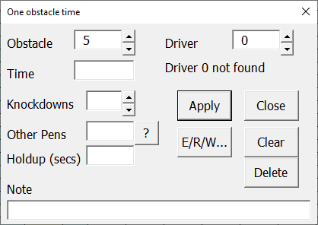
You can enter the time in any of the formats above.

It`s helpful to make a note, e.g. CEC obs1 (corrected error of course obstacle 1) etc for penalties. This appears in the Notes field.

For knockdowns, just set the number of knockdowns and the sheet gives you 2 penalties per knockdown.
Click “?” to see other penalties.
Holdup should just be in secs.

You can bring this form up by clicking Enter Obs, then set obstacle number and Driver number, by using the up down arrows or typing. If you click the cell for an obstacle for a driver then Enter Obs, the obstacle form will display that driver`s number and that obstacle number when it opens. If you click the up down arrows on the driver, the next driver in the marathon order will be displayed (because that is how scores normally come in).

Enter sections

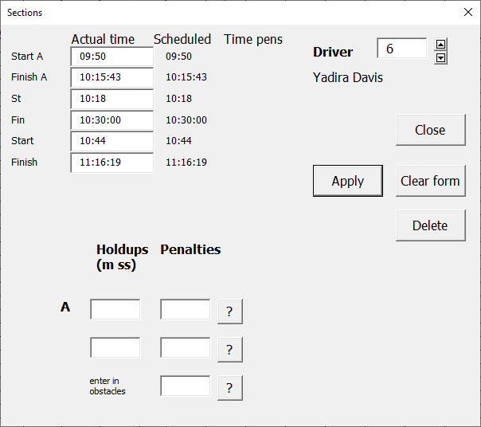
Enter the section times in the white boxes. Note that if you have used the marathon times sheet, the expected times appear as defaults and as a sanity check – you can just edit them. You can enter the times as:
- Excel`s native time format H:m:s e.g 14:54:07 or
- hhmmss e.g 145407 - easier to type

Check the calculated “Time pens” (time penalties), especially unusually large ones, mainly to see that the times have been correctly entered.

You can also enter any section holdup times and penalties along the way. Section B holdups and penalties are normally entered in the individual obstacles forms.

If you are not timing the Transfer section (Walk), perhaps at a club event, or don’t have a Section A, you can simply leave the times as the scheduled times and 0 penalties will be applied.

Click “?” for other penalties on the sections, or simply enter them as numbers.

To print

Click one of the Print buttons at the top of the Master sheet to print dressage, or dressage + cones, or marathon, summary or all.
(Or use the menu entries) Scoring > Print All etc)

The system will make you a copy to be printed on the sheet called Printing. You can delete things or alter them on this sheet – Printing – for print – without affecting your Master score sheet.

Remember to click Master (tab at the bottom) to get back to enter more scores – the Printing sheet is just a temporary sheet for printing. You can of course copy any print sheet to a spare worksheet if you need to keep it.

A dialog is displayed to let you choose which class(es) to print:

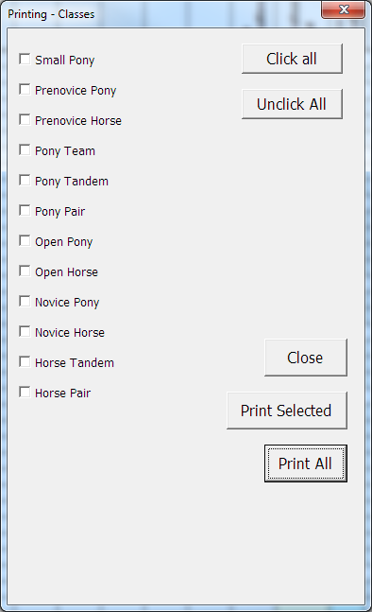

During the day you may wish to print only those classes complete, or fairly complete.

“Print All” prints all the classes regardless of check boxes. “Print Selected” prints only those classes with ticks in their checkboxes. You can put ticks in all the boxes by clicking Click All. That`s quicker if, for example, you want to print all but one or two classes (which you then unclick).

Click the Master tab at the bottom of the spreadsheet to get back to enter scores.

The “More” form

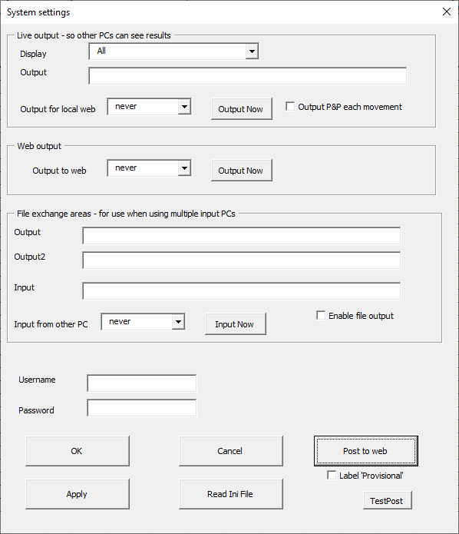
Use “Post to web” if you are connected to the internet and your results will be sent to www.hdtforum.co.uk.
You can also use the button Post on the top right of the Master scoresheet to post to the web without leaving the master scoresheet, alternatively you can set Web output – Output to web and the spreadsheet will post automatically

You will be able to view the results immediately, by looking at www.hdtforum.co.uk/scores in an internet browser and selecting your club and event. A new folder will automatically be set up for your club if you haven`t posted before. Use the Region/club “Test” if you need to experiment.

Be sure you have set the event name and date first, in Details tab as usual, so you can find your results and don`t overwrite a previous event.
Set your club name on the details tab under Region/club: all your club results posted will be collected under your club name.
Set the date to be the first day of your event – the system needs a single date to file the event results, even if it is two or three days long.

You can update the posted results as often as you like – for instance to keep people updated during an event.
You might wish to label these results `Provisional` by clicking that check box before posting, until the results are finalised when you can clear the check box `Provisional` and do a final Post..

You can try this out any time – for testing, call your Region/club “Test”, and press Post to web. Now go to www.hdtforum.co.uk/scoring and select the region Test to see your results. Change a result, press Post to web again, and refreshing your browser view will show the new scores. (Test results are temporary and will be deleted from time to time – `real` results – I.e. not in region Test, will not.
(Note: all posting needs a username password, as above – you don`t; want other people overwriting your results – please email me or call me for a password. You only need to enter it once – your PC will remember it).
Once you have entered your username password once on a PC it will remember it – then you can Post simply by clicking Post on the Master sheet – whenever you are connected to the internet.

Late changes to drivers/classes
Always use the Add/Move/Delete button if you have to change a driver or add one once you’ve made the scoresheet or started scoring. Don’t try deleting or inserting rows directly in Excel unless you’re an Excel expert.

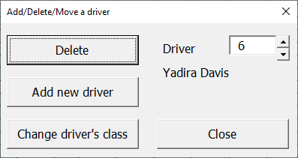

You can Delete (normally it is better to label a driver Retired or Withdrawn at this stage), but Delete removes them completely.

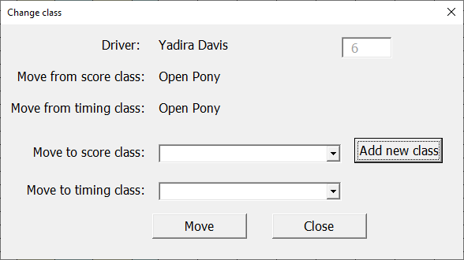

Click “Change drivers class” to get a dialog to change their class (choose one from the pull down or Add a new one):

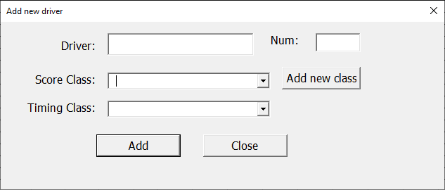

“Add new driver” lets you add a late or mislaid entry:

If you use these functions, be sure to check your MarathonTimes and DressageTimes tabs and adjust your timetable as needed.

Live output - advanced

Creates a local web site which can be used to display on any number of other PCs e.g by wifi to display the score around a site.
File exchange areas - Input and Output are about using multiple PCs to input/share scores for big events needing several scorers.
If you are likely to use these features, please ask me for the separate document describing them.

FAQs

How do I set up a Derby or Combined marathon?
A Derby or Combined marathon will usually have different penalties per knockdown and per second in the obstacles form a ‘normal’ event. Set these on the Details page, usually 1 penalty per second and 3 penalties for a knockdown.

Usually there is just Section B. Hide the columns for Section A and Transfer in the Master tab when you have created the scoresheet for scoring.
In the MarathonTimes tab you can set Section A and Transfer length to 0 and the time gap between sections to zero, then schedule as usual. Hide the unwanted columns (Section A times etc) before publishing to drivers and stewards.

What do I do if some people in a class get different marathon section times?
Some clubs run small pony scored in with another class, for example, but want them to have different marathon and cones speeds although running in the same class. That needs a bit of manual intervention as each competitor is in only one class:

Using a Small Pony in Open Pony as an example, probably the easiest/clearest way to do this is:

1 Generate the Marathon Times as normal with the small pony as Small Pony class in their class column on Marathon Times.

2 In the Drivers tab, label the Small Pony drivers Open Pony so they will be scored with Open Pony.

3 Generate the master score sheet.

4 On the Master score sheet, change the Small Pony driver`s class from Open Pony to Small Pony in column DI. That automatically gives them Small Pony cones and marathon times.

(You can just unprotect the Master temporarily and overtype the cones and section time allowed in the Master spreadsheet, but the above may be less prone to error.)

What if the TD varies the marathon speed?

Change the Time allowed in the MarathonTimes sheet, either by typing in new values (column D,F,I) or by changing the speed (column R,S,T) and clicking “Use these times”
. Check the competitors` finish times are still spaced apart OK. The Master sheet will recalculate, including any existing scores.

What if the TD changes the cones time?
Go to the Details screen and adjust for the changed class. It`s easiest to edit the distance, and the time adjusts, but you can edit the time direct if you unprotect the sheet. The new cones time allowed will automatically update the master sheet and its calculations.

How do I work out King of the Cones?

Click Print King of Cones, or look at the King Cones column (BX) on the Master scoresheet. That shows how many seconds under the class time a driver was provided they are clear on cones. Biggest number wins.

What if I don`t use Standing Presentation?

Simply leave the scores blank. You can hide the columns for this in the Master sheet if you like, Details should do this for you.

What if I use the Walk instead of Transfer?

It makes no difference to the scoring. Set the time for the Transfer as you wish, edit the name of the section if you like.

What if I get a late entry?

Use Add Move Delete button on the Master tab – see “Late changes to drivers/classes” above.

My buttons don’t do anything

Make sure you have enabled ‘active content’/macros in your spreadsheet.
For more information on this Google “enable active content in Excel”. The exact way to do this varies between Excel versions. For example in Excel 2010, click File > Options > Trust Center > Trust Center Settings…

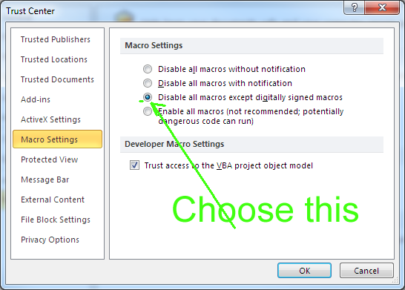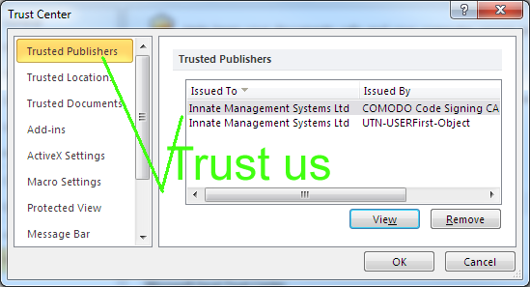

The spreadsheet is digitally signed with my company, Innate, signature althoug it is written by me, not Innate. Trusting my signature allows it to run, without allowing other possibly malicious spreadsheets to run code.

If this doesn’t fix it, you may have a Microsoft update issued December 2014 which stopped all user buttons working on Excel spreadsheets(!?).
If you have this problem, please apply the fix in the following Microsoft Knowledgebase article:
http://support.microsoft.com/kb/3025036
scroll down to where it says Fixit, click that and allow it to run.

Finally

These are brief notes to get you started. It`s best to play with it away from the pressure of an event – you can make copies, experiment, throw away your practice ones.

Remember to save your spreadsheet at frequent intervals, just in case, for instance your PC crashes for any reason. Always keep the dressage sheets and paper scores from the stewards until you have a printout of the results for that competition/class, and normally until the end of the event in case of queries

Security

The VBA (`Macros`) are digitally signed using my company (Innate`s) code signing certificate – this gives you some guarantee that it hasn`t been tampered with and is not malware – in general it`s not a good idea to run unsigned macros.

The spreadsheet is free and `open` so you can see all formulas and the VBA (Visual Basic for Applications) which creates the forms. If you alter anything, please make a note! If you make improvements, please share and let me know.

This spreadsheet is produced by me Mike Watts as a personal activity. It is not a product of my company, Innate. While it has been carefully evolved over the years, no guarantees!

Names, characters, businesses, places, events, locales, and incidents are either the products of the author's imagination or used in a fictitious manner. Any resemblance to actual persons, living or dead, or actual events is purely coincidental

Licence

MIT License

Copyright (c) 2011-2020 Mike Watts www.mikewatts.com

Permission is hereby granted, free of charge, to any person obtaining a copy
of this software and associated documentation files (the "Software"), to deal
in the Software without restriction, including without limitation the rights
to use, copy, modify, merge, publish, distribute, sublicense, and/or sell
copies of the Software, and to permit persons to whom the Software is
furnished to do so, subject to the following conditions:

The above copyright notice and this permission notice shall be included in all
copies or substantial portions of the Software.

THE SOFTWARE IS PROVIDED "AS IS", WITHOUT WARRANTY OF ANY KIND, EXPRESS OR
IMPLIED, INCLUDING BUT NOT LIMITED TO THE WARRANTIES OF MERCHANTABILITY,
FITNESS FOR A PARTICULAR PURPOSE AND NONINFRINGEMENT. IN NO EVENT SHALL THE
AUTHORS OR COPYRIGHT HOLDERS BE LIABLE FOR ANY CLAIM, DAMAGES OR OTHER
LIABILITY, WHETHER IN AN ACTION OF CONTRACT, TORT OR OTHERWISE, ARISING FROM,
OUT OF OR IN CONNECTION WITH THE SOFTWARE OR THE USE OR OTHER DEALINGS IN THE SOFTWARE.

Latest changes

See “Changes” on the Details page of the scoring template for the latest information.

